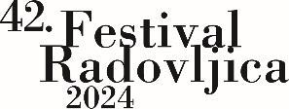

**From Scribe to Stage**

**International Audience Engagement Workshop**

**Radovljica, 21 and 22 August 2024**

**APPLICATION FORM**

CONTACT INFORMATION

Name and surname:

Country of residence:

E-mail:

Phone number (optional):

Experience with early music:

DEADLINE FOR APPLICATIONS: the call for proposals will be open until **15 August 2024**.

Applications can be sent by e-mail (mi@zrc-sazu.si) or by post to the following address: ZRC SAZU, Muzikološki inštitut, Novi trg 2, SI–1000 LJUBLJANA.

Signature:

Date:

* Your data will be used for the sole purpose of organising this workshop.